AutoEmail AEFUPE and AEFUIE Tests
Tester: Tony Tasker
Date: 24th January 2017
Time: 10:30
PC/Server: TonyTasker-PC
Database: CABS_TEST (Copy of live SHU DB)
Works Summary: N/A
Works Order: N/A
Task: N/A
Notes: These tests were performed using Microsoft SQL Server Management Studio. Output to the Results and Messages Output Windows are used to determine the success of the tests. Also the receipt of emails.

Testing to ensure recent changes to AEFUPE and AEFUIE resulted in:

- AEFUIE – only functions with a total invoice value which is non zero will be added to the function list

- AEFUPE – functions will only appear in the list if, when posted, the total invoice value will be non-zero

Pre-Test Setup
No | Task | Tester | Pass | Notes
1 | In X CABS Config, Section CABS_AUTO_EMAIL_FUNCS if WIPWindow is set then  WIPWindow=0  Set DebugFlag=1  In section CABS_AUTO_EMAIL_FUNCS_Trigger  Set DebugFlag=1 | TT

Post-Test Setup
No | Task | Tester | Pass | Notes
1 | Reverse any Config Changes in X CABS Config | TT

Tests

Uninvoiced Events – AEFUIE
No | Test | Tester | Pass | Notes
1 | In CABS locate an Event to test with:  SELECT AC_OWNER, FT.F_OWNER FROM FOL_TRAN FT  INNER JOIN FUNC_FIL ON F_REF = FT.F_OWNER  INNER JOIN AC07 ON F_SOURCE = AC_OWNER  INNER JOIN CT07 ON AC_CODE = CT_CODE  INNER JOIN OP_FILE ON dbo.uf_Get_FirstName_From_CT_DESC(CT_DESC) = O_FIRST AND dbo.uf_Get_LastName_From_CT_DESC(CT_DESC) = O_LAST  WHERE F_INVDATE IS NULL AND F_ENDDATETIME < GetDate() AND F_VALUE <> 0 AND COALESCE(O_EMAIL, '') <> ''  GROUP BY AC_OWNER, FT.F_OWNER  ORDER BY AC_OWNER  Using M000847 (F004619) | TT |  | Looking for a function that has only a single posted, uninvoiced record in FOL_TRAN to enable easy testing
2 | Update the status of the email to not sent  UPDATE AEF_Link SET AEFL_SENT = 0, AEFL_CanSend = 1 WHERE AEFL_FREF = 'FFFFFFF'  Check status of AutoEmail Queue  SELECT * FROM vw_AEFLINK WHERE AEFL_FREF = 'FFFFFFF' | TT |  | For Email Template AEFUIE:  AEFL_CanSend should be 1,  AEFL_Sent should be 0,  SessionSendable should be 1,  Sendable should be 1,  MatchCriteria should be 1
3 | Process the AutoEmail  EXEC CABS_AUTO_EMAIL_FUNCS_SESS_CHECK | TT |  | Email delivered as per Figure 1  Note function F004619 is in the list
4 | Change the value of the FOL_TRAN record to 0 for function F004619  UPDATE FOL_TRAN SET F_VALUE = 0.00 WHERE F_OWNER = 'F004619' | TT
5 | Update the status of the email to not sent  UPDATE AEF_Link SET AEFL_SENT = 0, AEFL_CanSend = 1 WHERE AEFL_FREF = 'FFFFFFF'  Check status of AutoEmail Queue  SELECT * FROM vw_AEFLINK WHERE AEFL_FREF = 'FFFFFFF' | TT |  | For Email Template AEFUIE:  AEFL_CanSend should be 1,  AEFL_Sent should be 0,  SessionSendable should be 1,  Sendable should be 1,  MatchCriteria should be 1
6 | Process the AutoEmail  EXEC CABS_AUTO_EMAIL_FUNCS_SESS_CHECK | TT |  | Email delivered as per Figure 2  Note function F004619 is not in the list
7 | Reset value:  UPDATE FOL_TRAN SET F_VALUE = 270.00 WHERE F_OWNER = 'F004619' | TT

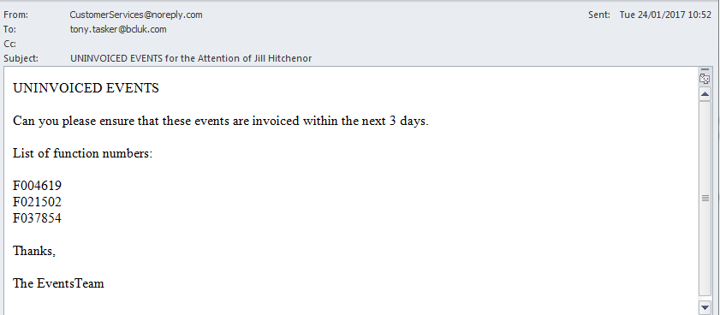
Figure 1 – Uninvoiced Event Email with F004619

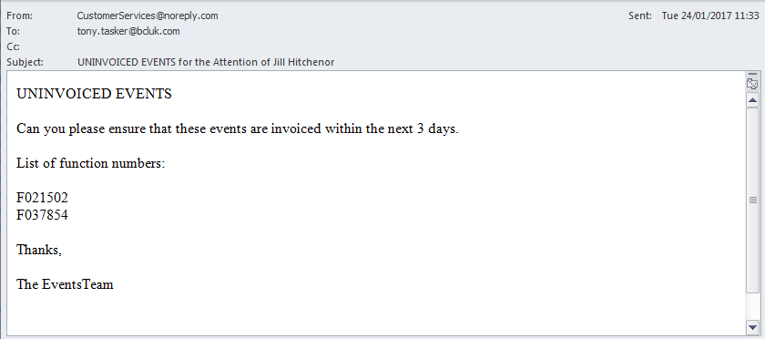
Figure 2 - Uninvoiced Event Email without F004619

Unposted EVENTS (AEFUPE)

No | Test | Tester | Pass | Notes
1 | In CABS locate an Event to test with:  SELECT AC_OWNER, FF.F_REF, dbo.FuncValue(FF.F_REF) FROM FUNC_FIL FF  INNER JOIN AC07 ON F_MBR_NO = AC_OWNER  INNER JOIN CT07 ON AC_CODE = CT_CODE  INNER JOIN OP_FILE ON dbo.uf_Get_FirstName_From_CT_DESC(CT_DESC) = O_FIRST AND dbo.uf_Get_LastName_From_CT_DESC(CT_DESC) = O_LAST  WHERE (dbo.FuncValue(FF.F_REF) <> 0 ) AND (DATEDIFF(DAY,FF.F_ENDDATETIME,GETDATE()) BETWEEN 0 AND 365) AND FF.F_STATUS = 'CONFRM'  GROUP BY AC_OWNER, FF.F_REF, dbo.FuncValue(FF.F_REF)  ORDER BY AC_OWNER  Used following queries to find a function that only has room charge:  SELECT ISNULL(sum(F_RM_CHG), 0)  FROM FUNC_FIL  WHERE F_REF = 'F117529'  AND F_RM_CHG <> 0  AND F_CUT <> 1  AND F_OFFRM <> 1  AND F_POSTED = 0  AND ( F_OWNER IS NULL  OR F_OWNER = ''  OR F_OWNER = F_REF )  SELECT ISNULL(sum(AI_COVERS * AI_CHARGE), 0)  FROM FUNC_FIL, AI_FILE, POST_DEF  WHERE AI_FREF = 'F117529'  AND AI_FREF = F_REF  AND P_CODE = AI_CODE  AND AI_CHARGE <> 0  AND AI_POSTED = 0  AND NOT ( P_COSTCENT = 'CCPAID' )  SELECT ISNULL(sum(PH_PRICE * PH_COVERS), 0)  FROM FUNC_FIL, PKGHEAD  WHERE PH_OWNER = 'F117529'  AND F_REF = PH_OWNER  AND PH_POSTED = 0  SELECT ISNULL(sum(MNM_PRICE), 0)  FROM FUNC_FIL, MASTMENU  WHERE MNM_OWNER = 'F117529'  AND MNM_OWNER = F_REF  AND MNM_PRICE <> 0  AND MNM_POSTED = 0  Using F117529 | TT |  | Looking for a function that has only a single unposted expense hat is a room charge to enable easy testing
2 | Update the status of the email to not sent  UPDATE AEF_Link SET AEFL_SENT = 0, AEFL_CanSend = 1 WHERE AEFL_FREF = 'FFFFFFE'  Check status of AutoEmail Queue  SELECT * FROM vw_AEFLINK WHERE AEFL_FREF = 'FFFFFFE' | TT |  | For Email Template AEFUPE:  AEFL_CanSend should be 1,  AEFL_Sent should be 0,  SessionSendable should be 1,  Sendable should be 1,  MatchCriteria should be 1
3 | Process the AutoEmail  EXEC CABS_AUTO_EMAIL_FUNCS_SESS_CHECK | TT |  | Email delivered as per Figure 3  Note function F117529 is in the list
4 | Change the value of the F_RM_CHG in FUNC_FIL for function F117529  UPDATE FUNC_FIL SET F_RM_CHG = 0.00 WHERE F_REF = 'F117529' | TT |  | Essentially sets total value of unposted invoice to 0.00
5 | Update the status of the email to not sent  UPDATE AEF_Link SET AEFL_SENT = 0, AEFL_CanSend = 1 WHERE AEFL_FREF = 'FFFFFFE'  Check status of AutoEmail Queue  SELECT * FROM vw_AEFLINK WHERE AEFL_FREF = 'FFFFFFE' | TT |  | For Email Template AEFUPE:  AEFL_CanSend should be 1,  AEFL_Sent should be 0,  SessionSendable should be 1,  Sendable should be 1,  MatchCriteria should be 1
6 | Process the AutoEmail  EXEC CABS_AUTO_EMAIL_FUNCS_SESS_CHECK | TT |  | Email delivered as per Figure 4  Note function F117529 is not in the list
7 | Reset value:  UPDATE FUNC_FIL SET F_RM_CHG = 58.50 WHERE F_REF = 'F117529' | TT

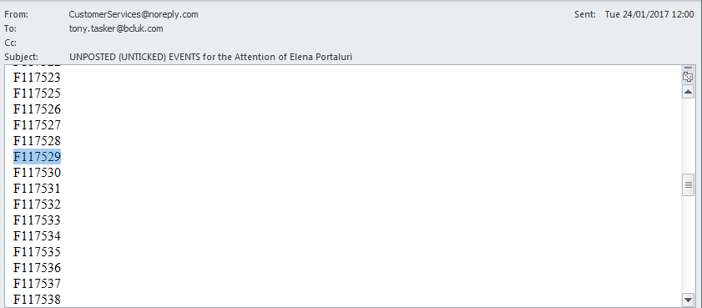
Figure 3 - Unposted Event Email with F117529

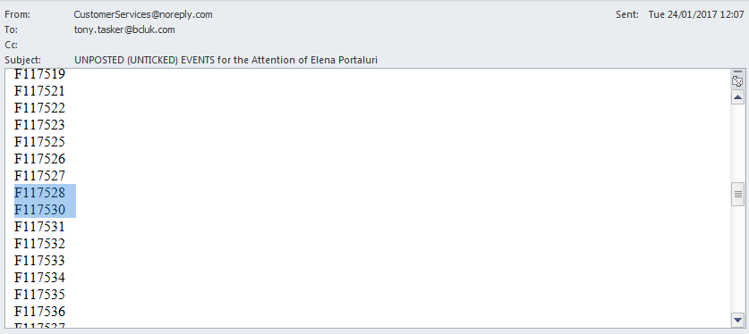
Figure 4 - Unposted Event Email without F117529

